INTERNSHIP REPORT

*A report submitted in partial fulfillment of the requirements for the Award of Degree of*

## BACHELOR OF TECHNOLOGY

**in**

## INFORMATION SCIENCE AND ENGINEERING

**By**

**Attulaya Kumar Singh**

## USN.: 1NT21IS037

**Under Supervision of Mrs. Swetha R**

## Nitte Meenakshi Institute of Technology

## Bangalore

**(Duration: 7th July, 2022 to 6th August, 2022)**



## DEPARTMENT OF INFORMATION SCIENCE AND ENGINEERING

## NITTE MEENAKSHI INSTITUTE OF TECHNOLOGY

(An Autonomous Institution)

Approved by AICTE, Affiliated to VTU, Belagavi

## Yelahanka, Bengaluru, Karnataka

## 2022 – 2023

**DEPARTMENT OF INFORMATION** **AND ENGINEERING**

**NITTE MEENAKSHI INSTITUTE OF TECHNOLOGY**

(An Autonomous Institution)

KARNATAKA



***CERTIFICATE***

This is to certify that the “**Internship report”** submitted by **ATTULAYA KUMAR SINGH (USN.: 1NT21IS037)** is work done by him/her and submitted during 2022 – 2023 academic year, in partial fulfillment of the requirements for the award of the degree of **BACHELOR OF TECHNOLOGY in INFORMATION SCIENCE AND ENGINEERING,** at **Nitte Meenakshi Institute of Technology.**

|  |  |  |
| --- | --- | --- |
| **Mrs. Swetha R**  **Project Coordinator,**  **Department of ISE** |  | **Dr. Mohan S G**  **Head of the Department,**  **Department of ISE** |

# ACKNOWLEDGEMENT

It is indeed with a great sense of pleasure and immense sense of gratitude that I acknowledge the help of these individuals.

I am highly indebted to Dean **Dr.V. Sridhar** and Principal **Dr. H.C. Nagaraj,** for the facilities provided to accomplish this internship.

I would like to thank my Head of the Department **Dr. Mohan S G** for his constructive criticism throughout my internship.

I would like to thank **Mrs. Swetha R,** internship coordinator Department of ISE for their support and advices to get and complete internship.

I am extremely great full to my department staff members and friends who helped me in successful completion of this internship.

**ATTULAYA KUMAR SINGH**

**(1NT21IS037)**

**INDEX**

# Table of Contents Pg.no.

# Internship Objectives………………………………………………..…………………vi

# Weekly Overview of Internship Activities…………………………….vii – viii

# IOT and ICT………………………………………………………………………………….9

# Projects made under IOT and ICT Training……………………………….9-11

# HTML/CSS Free Code Camp Certification………………………………..12-13

# Canva Certification………………………………………….......................................14

# Figma Prototyping……………………………………………………………………...15

# HTML/CSS Coding of Figma Prototype…………………………………...16-20

# C Language Certification………………………………….......................................21

# Conclusion………………………………………………………………………………....22

# Bibliography………………………………………………………………………………23

**Learning Objectives/Internship Objectives**

* Internships are generally thought of to be reserved for college students looking to gain experience in a particular field. However, a wide array of people can benefit from Training Internships in order to receive real world experience and develop their skills.
* An objective for this position should emphasize the skills you already possess in the area and your interest in learning more
* Internships are utilized in a number of different career fields, including architecture, engineering, healthcare, economics, advertising and many more.
* Some internship is used to allow individuals to perform scientific research while others are specifically designed to allow people to gain first-hand experience working.
* Utilizing internships is a great way to build your resume and develop skills that can be emphasized in your resume for future jobs. When you are applying for a Training Internship, make sure to highlight any special skills or talents that can make you stand apart from the rest of the applicants so that you have an improved chance of landing the position.

**WEEKLY OVERVIEW OF INTERNSHIP ACTIVITIES**

|  |  |  |  |
| --- | --- | --- | --- |
| **1st WEEK** | **DATE** | **DAY** | **NAME OF THE TOPIC/MODULE COMPLETED** |
| 07/07/22 | Thursday | Basic 20 Problems |
| 08/07/22 | Friday | Basic 20 Problems, Git and GitHub Intro |
| 09/07/22 | Saturday | Basic 20 Problems, Git and GitHub Intro |
|  |  |  |
|  |  |  |
|  |  |  |

|  |  |  |  |
| --- | --- | --- | --- |
| **2nd WEEK** | **DATE** | **DAY** | **NAME OF THE TOPIC/MODULE COMPLETED** |
| 11/07/22 | Monday | Canva/Figma Online Certification, HTML/CSS Free Code Camp Certification |
| 12/07/22 | Tuesday | Canva/Figma Online Certification, HTML/CSS Free Code Camp Certification |
| 13/07/22 | Wednesday | Canva/Figma Online Certification, HTML/CSS Free Code Camp Certification |
| 14/07/22 | Thursday | Figma Prototyping (E bike Web page Prototyping) |
| 15/07/22 | Friday | Figma Prototyping (E bike Web page Prototyping) |
| 16/07/22 | Saturday | Canva/Figma Online Certification, HTML/CSS Free Code Camp Certification |

|  |  |  |  |
| --- | --- | --- | --- |
| **3rd WEEK,** | **DATE** | **DAY** | **NAME OF THE TOPIC/MODULE COMPLETED** |
| 18/07/22 | Monday | HTML/CSS Website Coding (E-bike) |
| 19/07/22 | Tuesday | HTML/CSS Website Coding (E-bike) |
| 20/07/22 | Wednesday | HTML/CSS Website Coding (E-bike) |
| 21/07/22 | Thursday | C Language Certification |
| 22/07/22 | Friday | C Language Certification |

|  |  |  |  |
| --- | --- | --- | --- |
| **4th WEEK** | **DATE** | **DAY** | **NAME OF THE TOPIC/MODULE COMPLETED** |
| 25/07/22 | Monday | IOT and ICT Orientation |
| 26/07/22 | Tuesday | IOT and ICT Orientation |
| 27/07/22 | Wednesday | IOT and ICT Orientation |
| 28/07/22 | Thursday | IOT and ICT Orientation, Image Processing |
| 29/07/22 | Friday | IOT and ICT Orientation, HTML/CSS Free Code Camp Certification |
| 02/08/22 | Saturday | IOT and ICT Orientation, HTML/CSS Free Code Camp Certification |

# IOT (Internet of Things)

The **Internet of things** (**IoT**) describes physical objects (or groups of such objects) with sensors, processing ability, software, and other technologies that connect and exchange data with other devices and systems over the Internet or other communications networks. Internet of things has been considered a misnomer because devices do not need to be connected to the public internet, they only need to be connected to a network and be individually addressable.

# ICT (Information and Communication technology)

**Information and communications technology** (**ICT**) is an extensional term for Information Technology (IT) that stresses the role of Unified Communication and the integration of telecommunications (telephone lines and wireless signals) and computers, as well as necessary enterprise software, middleware, storage and audiovisual, that enable users to access, store, transmit, understand and manipulate information.

**Projects made under IOT and ICT training: --**

* **Need a E-Stroller –**
* Mommy wheels the baby out.
* Sometime she is not in the position to push it. So, we need some assistance.
* Sometime going down the slope the stroller pulls her and she is likely to fall.
* Sometime she has to handle it with one hand as she is taking her Knelling bag.
* I am worried that somebody will lift the baby when granny is busy knitting.
* She also needs some assistance while steering the stroller.

**Solution to the Problem Statement: --**

* Stroller moves only when one or both hands we keep on the handle.
* Automatic speed is set once started pushing.
* Emergency brakes and acceleration is applied.
* If stroller not touched for more than 10 min, notification is sent is sent.
* Check whether baby is present or not by sensing its weight.
* Sensitivity like alarm if baby is taken out from the stroller without password or fingerprint.
* By providing a screen on the stroller about the location and other details to assist.
* **Automatic Parking: --**
* You know I am always in a hurry to catch their flight.
* I don’t have time to search for a parking space in parking Lot.
* You know I am paranoid of somebody else driving the car.
* Design an automatic parking system for our Mercedes, you know it is drive by wire car.

**Solution to the Problem Statement: --**

* Sensor required: -

GPS tracking device

Automatic Driving device

Environment Sensor

Fingerprint Sensor

Payment Gateway

* GPS Tracking – With the help of satellite we would be tracking the empty parking lots in the parking area. It will also direct the automated driving system to nearest parking space.
* Automated Driving System – With the help of Artificial Intelligence and Data Science we would drive the vehicle as well as help in parking it.
* Environment Sensors – This Sensor will detect any obstruction around the vehicle and send the data to the Automated driving System. When the vehicle is parked and any intruder try to enter, it will pop up an urgent notification to owner.
* Fingerprint Sensor – For the sake of security of car, Fingerprint is installed and only owner is able to unlock and start the car.
* Payment Gateway (FASTag) – A quick payment gateway to pay at paid parking and save time.
* **Automatic Medicine Dispenser: -**
* You know papa and mamma have amnesia.
* They keep forgetting to take their pills regularly.
* Sometimes they get confused and interchange each other medicine.
* They need to get prescription for refill automatically from the doctor and doctor also need to know if they are taking their medicine properly.
* I also need to be kept updated on them of medicine consumed.

**Solution to the Problem Statement: --**

* IOT devices required for the dispenser: -

RFID (Radio Frequency Identification Owner)

Wi-fi module

Medicine Dispenser

Servo Motor

LCD Screen

AI enabled IC circuit.

* RFID reader – It will enable old age citizens to uses the automated medicine dispenser without any difficulty. RFID will read the 12-digit code and will dispense pills only when the customer or Automated Timer allow to dispense.
* Wi-fi module – Embedded wi-fi System will notify before a stipulated time to the customer mobile. Also, Wi-fi will help in voice control of the dispenser. Along with all these things, it will help in tracking medicines and notify when and where required.
* Medicine Dispenser – Main Component of the Automated dispenser. Store the Medicines and all other pills in optimum temperature. It will constantly send data to different component to dispense medicine on time.
* Servo Motor – With the help of AI enabled IC circuit the motor will pick medicine from dispenser and move it to the destination tray.
* Automated Timer – It will help in keeping the time and notify the IC circuit to dispense medicine after a stipulated time. Also, when the time is over, it notifies or alert the owner by a notification sound.
* LCD Screen – Help in displaying the information for example – Number of pills in dispenser, Temperature of the Dispenser, and different information related to dispenser.
* AI enabled IC circuit – With the help of AI we keep a track of different parts and with direct them how to work. AI will prescribe owner appropriate pills for small disease like cold, cough, fever etc.
* **Template Designing: -**

# HTML/CSS FREE CODE CAMP CERTIFICATION

* **HTML (HyperText Markup Language) -** The **HyperText Markup Language** or **HTML** is the standard markup language for documents designed to be displayed in a web browser. It can be assisted by technologies such as Cascading Style Sheets (CSS) and scripting languages such as JavaScript.

Web browser receive HTML documents from a web server or from local storage and render the documents into multimedia web pages. HTML describes the structure of a web page semantically and originally included cues for the appearance of the document.

HTML elements are the building blocks of HTML pages. With HTML constructs, images and other objects such as interactive forms may be embedded into the rendered page. HTML provides a means to create structured documents by denoting structural semantics for text such as headings, paragraphs, lists, links, quotes and other items. HTML elements are delineated by *tags*, written using angle brackets. Tags such as <**img** /> and <**input** /> directly introduce content into the page. Other tags such as <**p**> surround and provide information about document text and may include other tags as sub-elements. Browsers do not display the HTML tags but use them to interpret the content of the page.

* **CSS (Cascading Style Sheets) - Cascading Style Sheets** (**CSS**) is a style sheet language used for describing the presentation of a document written in a markup language such as HTML or XML (including XML dialects such as SVG, MathML or XHTML). CSS is a cornerstone technology of the World Wide Web, alongside HTML and JavaScript.

CSS is designed to enable the separation of presentation and content, including layout, colors, and fonts. This separation can improve content accessibility; provide more flexibility and control in the specification of presentation characteristics; enable multiple web pages to share formatting by specifying the relevant CSS in a separate .css file, which reduces complexity and repetition in the structural content; and enable the .css file to be cached to improve the page load speed between the pages that share the file and its formatting.

Separation of formatting and content also makes it feasible to present the same markup page in different styles for different rendering methods, such as on-screen, in print, by voice (via speech-based browser or screen reader), and on Braille-based tactile devices. CSS also has rules for alternate formatting if the content is accessed on a mobile device.

**Certificate earned under HTML/CSS Free Code Camp Online Certification: --**

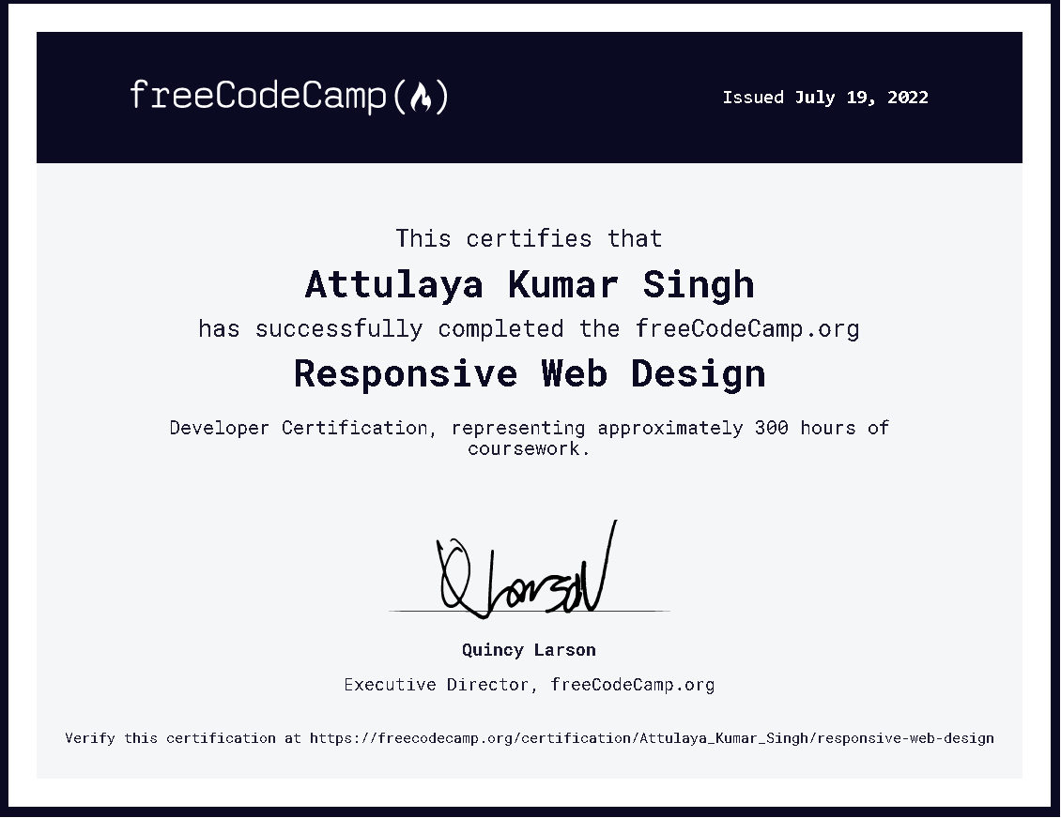

# CANVA CERTIFICATION: -

* **CANVA TOOL - Canva** is an Australian graphic design platform, used to create social media graphics, presentations, posters, documents and other visual content. The app includes templates for users to use. The platform is free to use and offers paid subscriptions such as Canva Pro and Canva for Enterprise for additional functionality. In 2021, Canva launched a video editing tool. Users can also pay for physical products to be printed and shipped

**Certificate earned under Canva Certification Course: --**

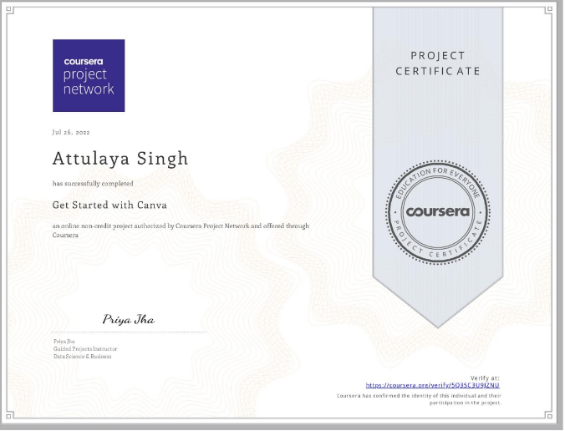

# FIGMA PROTOTYPING:

# Team Members: -

# Attulaya Kumar Singh – 1NT21IS037

# Niraj Agarwal – 1NT21IS103

# Topic: -

# Create a Figma Prototype on a E-bike that must be responsive and have basic animation.

# Link to the Figma Prototype: -

# https://www.figma.com/file/Yvob3HjFqsMbdEdhZsLrYe/NagaMoto?node-id=0%3A1

# HTML/CSS CODING OF FIGMA PROTOTYPE:

# Topic: -

# Our team were asked to code our Figma Prototype website with the help of HTML and CSS. So here are the screenshots as well as their respective code.

# [Website WinRAR Link](https://drive.google.com/file/d/1d8hzhYZy_pickdWBEV9tIAlT-b3Px4Hz/view?usp=sharing)

**HOME PAGE**

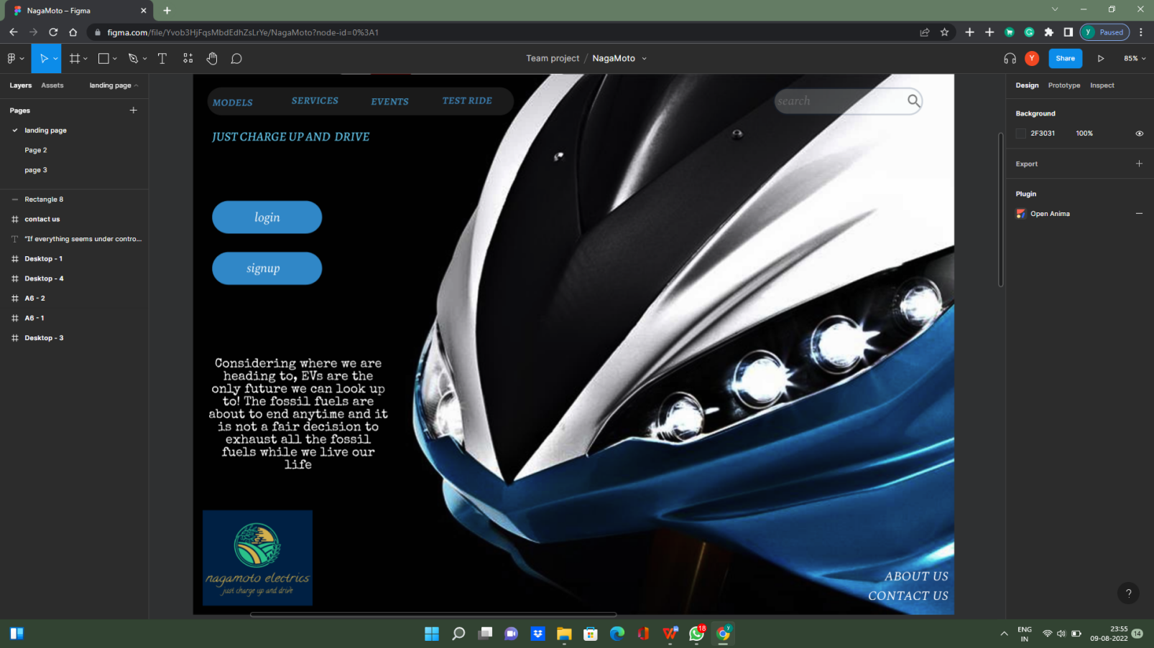

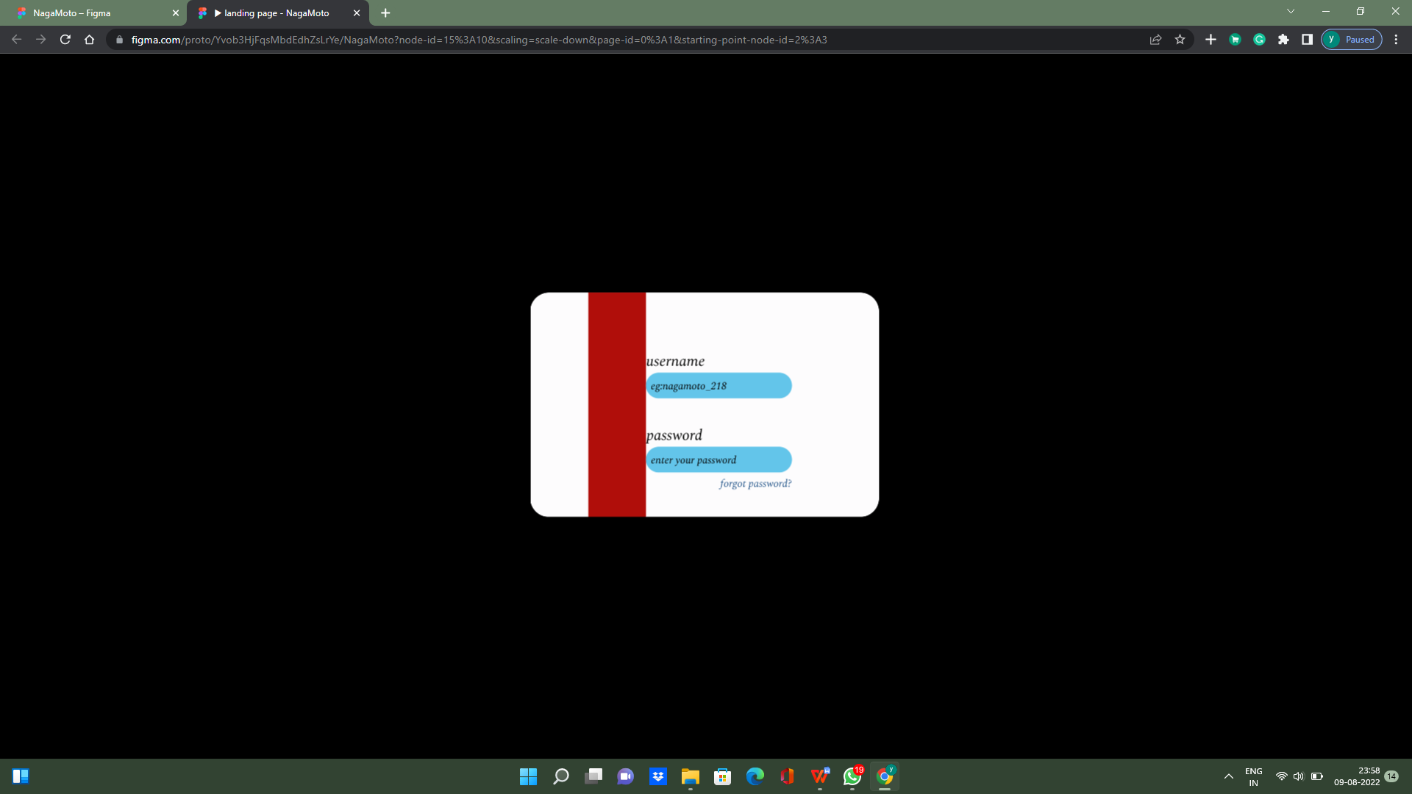

**LOGIN PAGE**

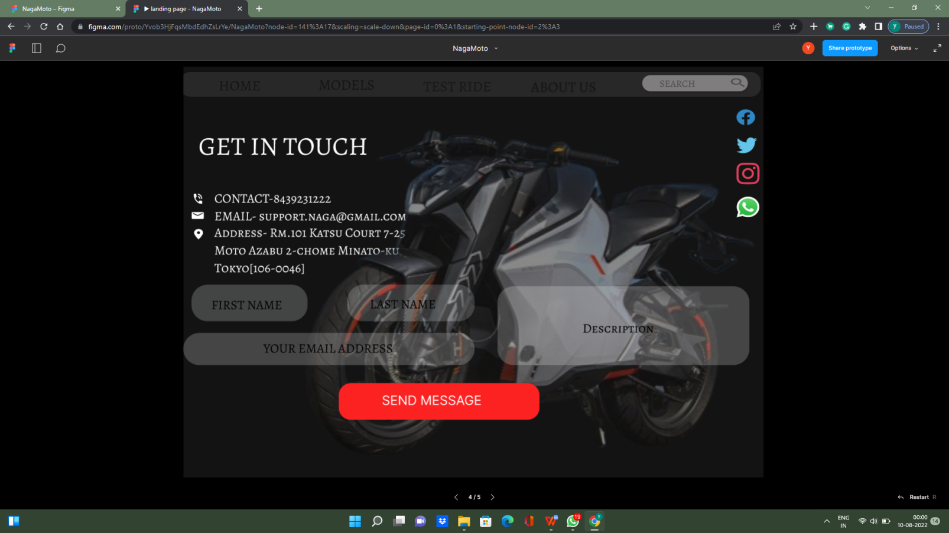

**CONTACT US PAGE**

**BIKES PAGE**

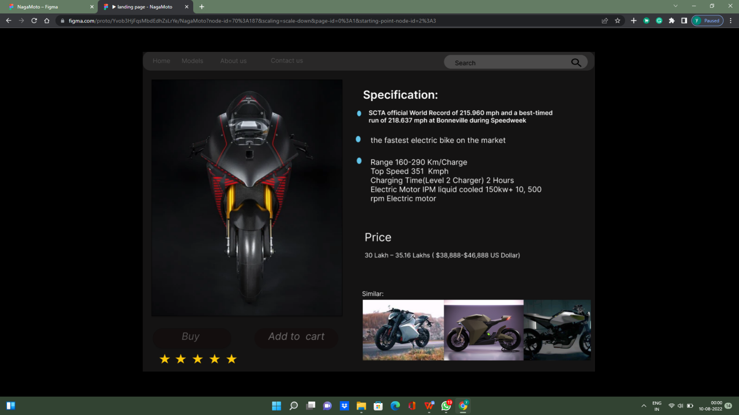

**MORE SPECS… PAGES**

# C LANGUAGE CERTIFICATION:

* **C Language** – **C** is a general-purpose computer programming language. It was created in the 1970s by Dennis Ritchie, and remains very widely used and influential. By design, C's features cleanly reflect the capabilities of the targeted CPUs. It has found lasting use in operating systems, device drivers, protocol stacks, though decreasingly for application software. C is commonly used on computer architectures that range from the largest supercomputers to the smallest microcontrollers and embedded systems.

A successor to the programming language B, C was originally developed at Bell Labs by Dennis Ritchie between 1972 and 1973 to construct utilities running on Unix. It was applied to re-implementing the kernel of the Unix operating system. During the 1980s, C gradually gained popularity. It has become one of the most widely used programming languages, with C compilers available for almost all modern computer architectures and operating systems. C has been standardized by ANSI since 1989 (ANSI C) and by the International Organization for Standardization (ISO).

# CONCLUSION

# Internship and Training is an integral part of Engineering student. And by giving us a chance to train our skills and mind to be industry ready Department of Information Science, Nitte Meenakshi of Technology has given a chance to grow in our respective field. By the end of this Internship Our team as well as the students of our department have manifested some of the future needs of IT Industry. I would like our Head of Department Mr. Mohan Kumar S.G. and our internship coordinator Ms. Swetha to guide us to throughout these days and help us at every point of difficult. They have also some appropriate facilities that assisted us during our Training.

# In this 1-month span, we have learned about basic Git and GitHub commands, Some IOT and its implementation in real life. We learnt how IOT and ICT affects our Human World and how it makes an easy place. Also, we learnt about Figma Tool and its importance in Website Prototyping. It is a beneficial tool for all the web developers. Also learnt some programming languages like HTML, CSS and C. These languages are Industry needed languages and will surely help in near future.

# BIBLOGRAPHY

# IOT Lab of NMIT

# Free Code Camp - [FreeCodeCamp](https://www.freecodecamp.org/)

# Coursera - [Coursera](https://in.coursera.org/)

# Figma - [Figma](https://www.figma.com/?fuid=)

# VS Code

# Great Learning - [GreatLearning](https://www.mygreatlearning.com/)

# All the Faculties of ISE Dept.

# My friends and family

# My LAPTOP…